✴

**Build empathy**

The information you add here should be representative of the observations and research you've done about your users.

Empathy map

Use this framework to develop a deep, shared understanding and empathy for other people. An empathy map helps describe the aspects of a user's experience, needs and pain points, to quickly understand your users’ experience and mindset.

# Says

What have we heard them say?

What can we imagine them saying?

# Thinks

What are their wants, needs, hopes, and dreams? What other thoughts might influence their behavior?

The Health Problems by un-hygienic usage of restrooms

We want the solution for the Hygiene problem caused by the bacteria’s

There is a possibility of bacterial infections for the peoples

they want when human enter the restroom then the door open automatically

IoT based weather adaptive Street Lighting System

some people have their own sanitizers.

some people have gloves.

they feel very bad about their situation

Some peoples are physically challenged , so they can’t enter the door by push/pull.

So the public get panicked to go for a public restrooms

[**Share template feedback**](https://muralco.typeform.com/to/CiqaHVat?typeform-source=app.mural.co)

# Does

What behavior have we observed? What can we imagine them doing?

# Feels

What are their fears, frustrations, and anxieties? What other feelings might

influence their behavior?

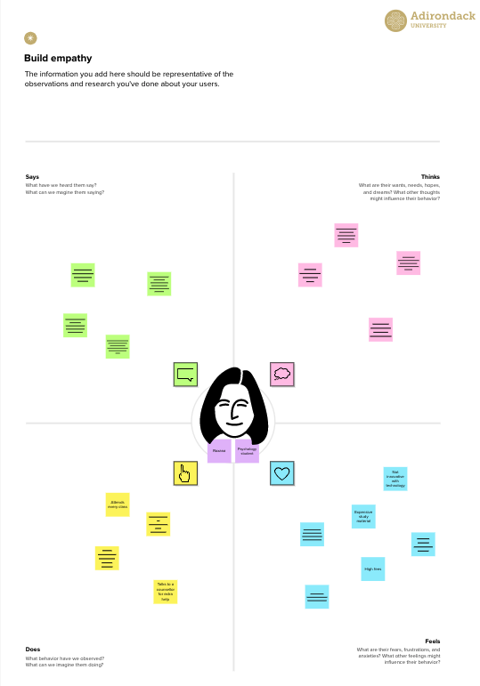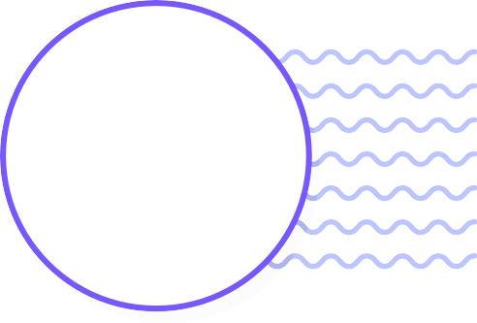

**Template**

**Need some inspiration?**

See a finished version of this template to kickstart your work.

[**Open example**](https://app.mural.co/template/f44b7843-7c23-408c-bd36-7b0c9409dc20/96efd10c-81d2-401e-8072-4e87935e5d6b)